**DAY-9**

**NAME: SUDHA SREELATHA**

**EMP ID: 46255249**

**Q1. Table enhancement using append structure.**

**Requirement:**

**Append custom fields ZZDISCOUNT1 to ZZDISCOUNT5 in the standard table SFLIGHT.**

This table is used to store flight details such Flight Date, Airfare, Maximum capacity in economy class, and Occupied seats in economy class for an airline carrier and needs to be enhanced to store discounts available for each flight if applicable.

**Transaction –** Use your own Tcode like ZYP01…ZY to display data

APPEND STRUCTURE:

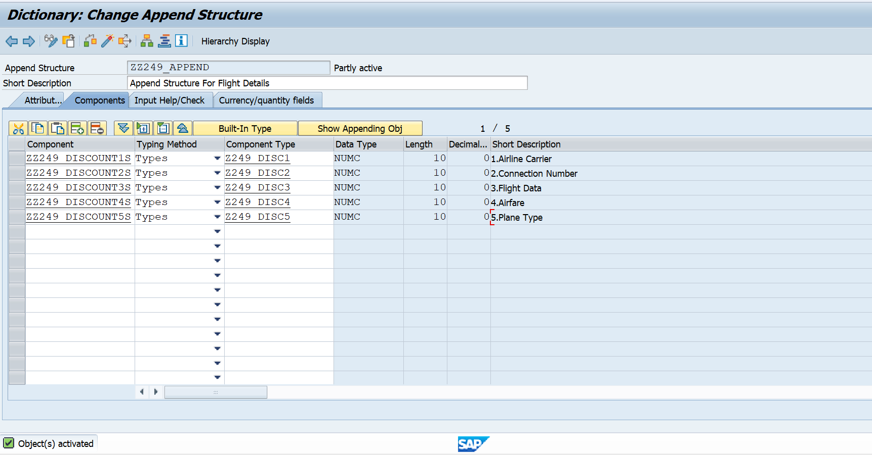

T-CODE:

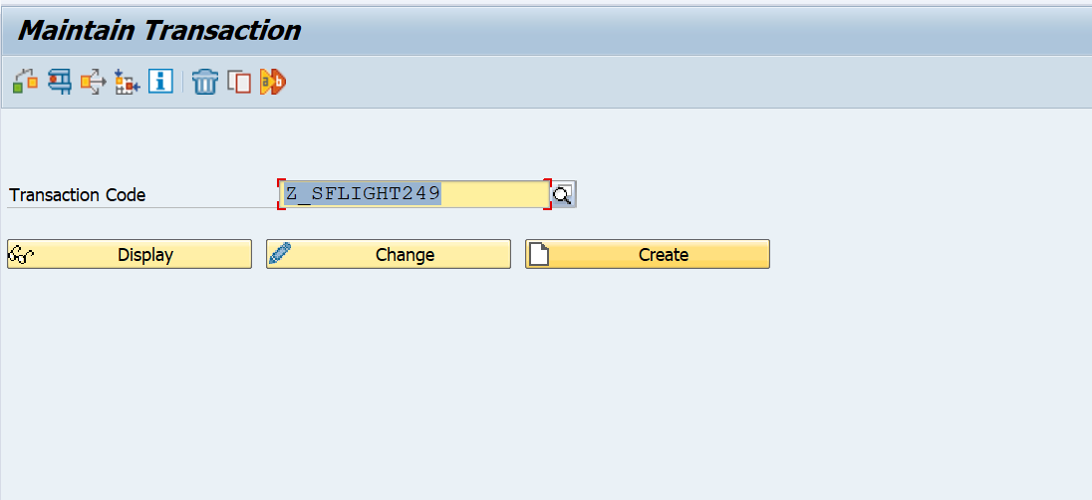

OUTPUT:

**Q2. Table enhancement using Customizing Include.**

**Requirement:**

**Append custom fields ZZNAME1 to ZZNAME5 in the standard table EKKO *using* customizing include if available.**

This table is used to store purchase order details, which needs to be enhanced to store usernames that creates the purchase orders.

**Transaction –** ME21N, ME22N & ME23N is used to create, change, or display purchase orders.

**Q3. Text enhancements.**

**Requirement: Change field labels and documentation for transaction** ZYP01 **as requested by the end user who is using this transaction to maintain flight data.**

1. Airline Carrier should be renamed as Carrier Name.
2. Connection Number should be renamed as Flight Number.
3. Flight Data should be renamed as Carrier Date.
4. Airfare should be renamed as Carrier Fare.
5. Plane Type should be named as Carrier Type

**CMOD:**

Filed labels

Airline carrier - CARRID - S_CARR_ID

Flight number - CONNID - S_CONN_ID

Carrier Dare - FLDATE - S_DATE

Carrier Fare - PRICE - S_PRICE

Carrier type - PLANETYPE - S_PLANETYE

**Airline carrier - CARRID - S_CARR_ID:**

**Flight number - CONNID - S_CONN_ID:**

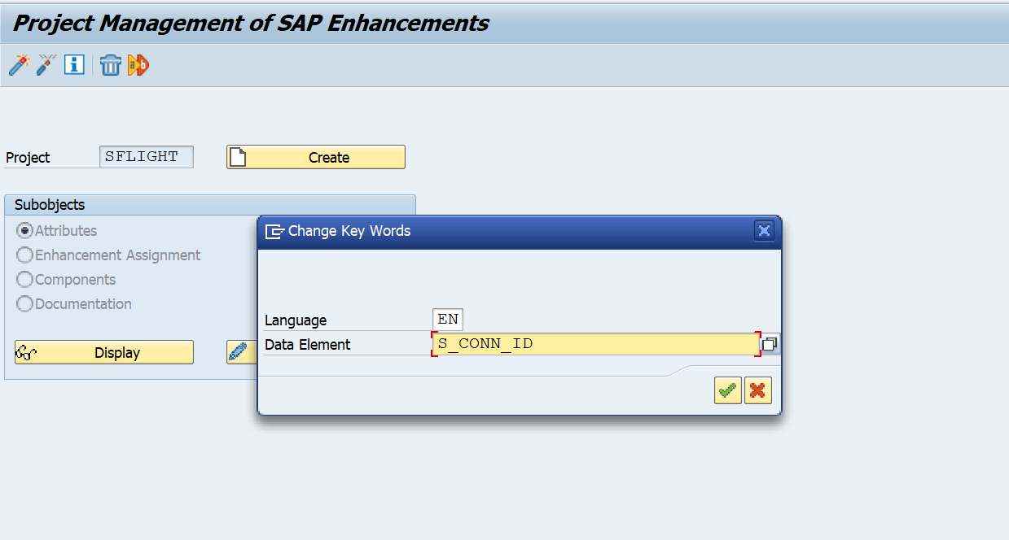

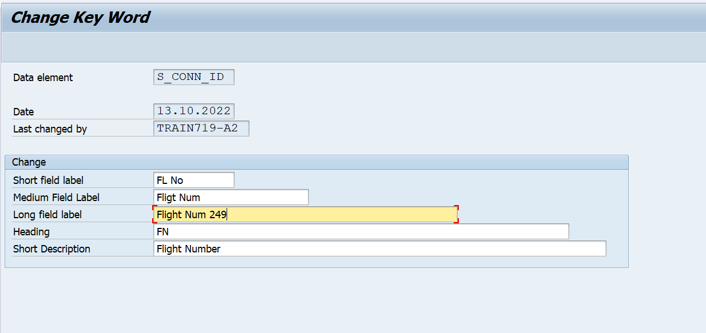

**Carrier Dare - FLDATE - S_DATE:**

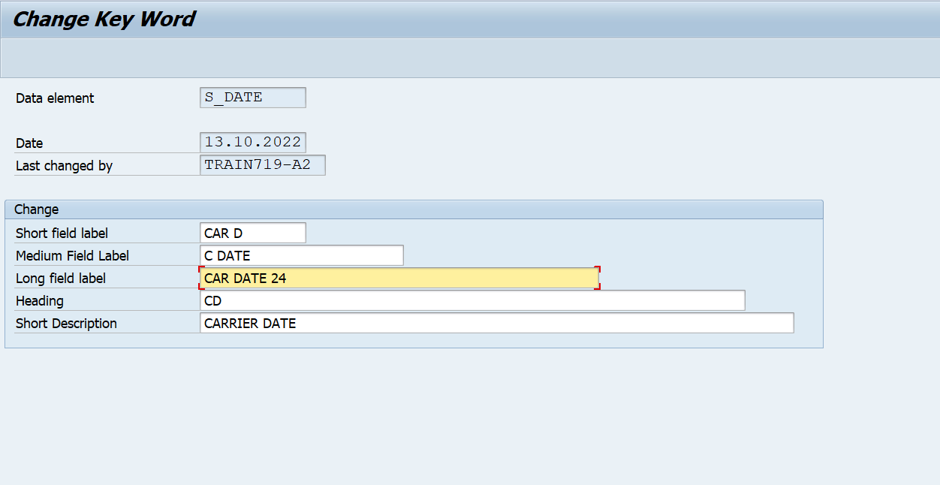

**Carrier Fare - PRICE - S_PRICE:**

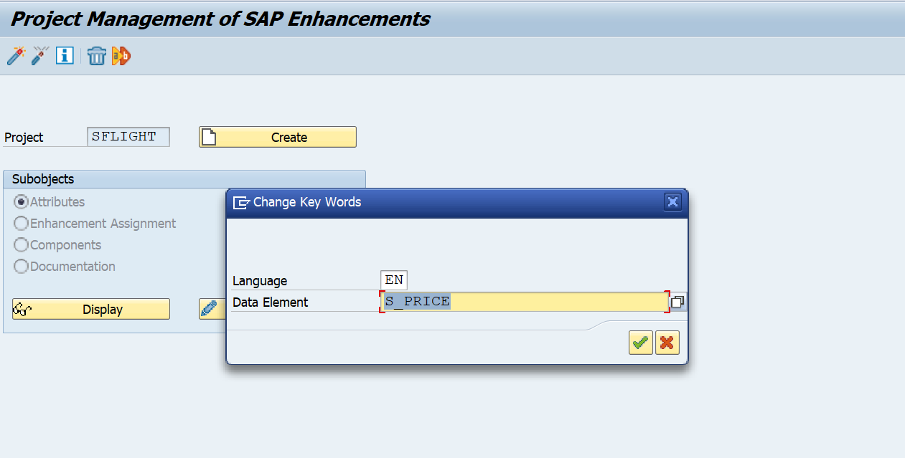

**Carrier type - PLANETYPE - S_PLANETYE:**

**Documentation:**

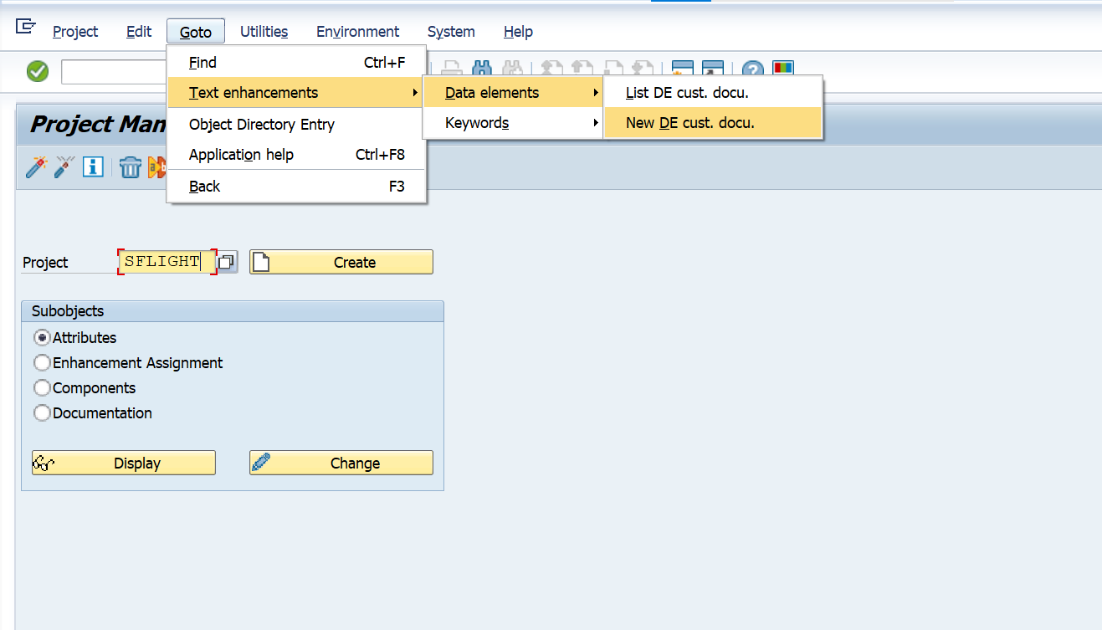

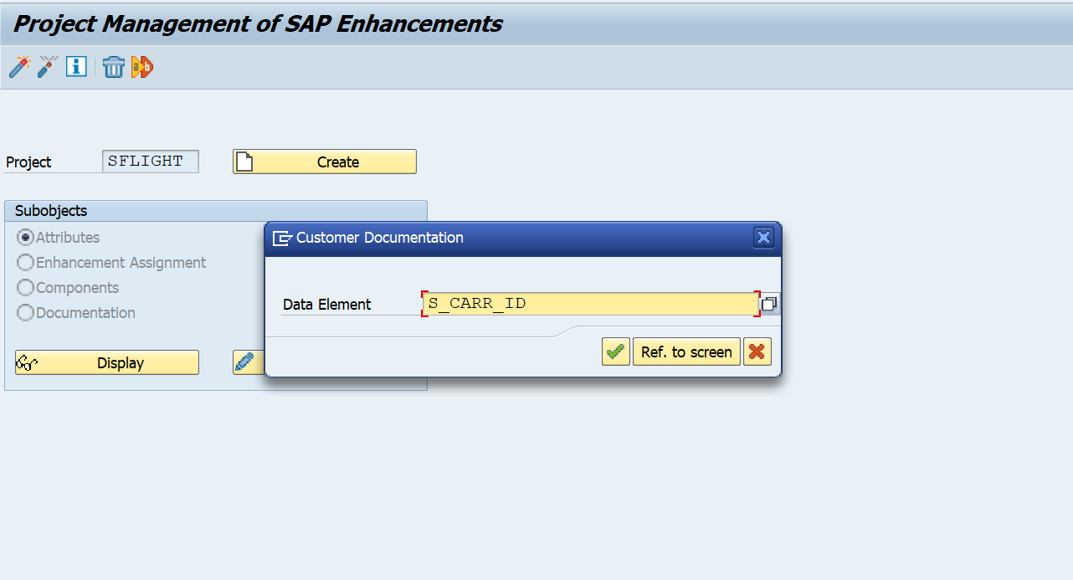



**Q4. Customer exits**

2. Create a project in CMOD, Assign Enhancement in Project. Inside Enhancement Module Write Custom Code.

